*FoundIt: Your Campus Return & Recovery*

1st Sanket S. Raskar

*Department of Computer Science and Engineering* *Dr. D. Y. Patil Pratisthan’s College Of Engineering, Salokhenagar, Kolhapur.*

[sanketraskar25@gmail.com](mailto:sanketraskar25@gmail.com)

3rd Siddhesh I. Kamble

*Department of Computer Science and Engineering Dr. D. Y. Patil Pratisthan’s College Of Engineering, Salokhenagar, Kolhapur.*

kamblesiddhesh09@gmail.com

2nd Sanket S. Chougule

*Department of Computer Science and Engineering*

*Dr. D. Y. Patil Pratisthan’s College Of*

*Engineering, Salokhenagar, Kolhapur.*

[sanketchougule@gmail.com](mailto:sanketchougule@gmail.com)

4th Ganesh S. Kokate

*Department of Computer Science and Engineering*

*Dr. D. Y. Patil Pratisthan’s College Of*

*Engineering, Salokhenagar, Kolhapur.*

[ganeshkokate25@gmail.com](mailto:mnmn172534@gmail.com)

5th Vishal N. Kshirsagar

*Department of Computer Science and Engineering*

*Dr. D. Y. Patil Pratisthan’s College Of*

*Engineering, Salokhenagar, Kolhapur.*

[*vishalkshirsagarmain@gmail.com*](mailto:vishalkshirsagarmain@gmail.com)

***Abstract*— The abstract briefly summarizes the problem, solution, and significance of *FoundIt: Your Campus Return & Recovery*. This web-based platform addresses inefficiencies in traditional lost and found systems on college campuses by digitizing the process of reporting and retrieving lost items. Users can search for or report items, leveraging real-time notifications and a secure verification process. Features like multi-language support and automated notifications enhance accessibility and usability, providing a scalable, efficient, and user-friendly solution.**

***Keywords: Lost and Found System, Campus, Multi-language Support, Digital Platform, Verification Process.***

1. Introduction

The traditional lost and found systems used on college campuses often rely on manual processes, which are time-consuming, inefficient, and inconvenient for both students and staff. In these systems, individuals who lose items must repeatedly visit a designated office to inquire about their belongings, while those who find items are required to deposit them at the same location. This reliance on physical interactions and outdated record-keeping methods results in significant delays, misplaced items, and the potential for wrongful claims due to the lack of a secure verification process. Moreover, the absence of remote access or real-time updates adds to the frustration of users, especially those with busy schedules or accessibility challenges.

*FoundIt: Your Campus Return & Recovery* addresses these shortcomings by introducing a fully digital, web-based solution that streamlines the process of reporting and retrieving lost items. The platform allows users to report found items with partial details and search for lost belongings using filters such as item type, color, and location. To ensure security, it incorporates a verification system based on security questions, significantly reducing the risk of fraudulent claims. With features like multi-language support, real-time notifications, and an administrative panel for resolving disputes, *FoundIt* aims to modernize lost and found management, offering a more user-friendly, efficient, and reliable solution tailored to the needs of a diverse campus community.

1. Finding lost items

In a college campus environment, losing personal belongings is a frequent issue faced by students, faculty, and staff. Commonly lost items include stationery, gadgets, ID cards, wallets, and other everyday essentials. The process of finding lost items on campus can be challenging due to the vast area and multiple buildings, making it difficult to retrace steps or pinpoint the exact location where the item might have been misplaced. Traditional strategies, such as physically revisiting potential locations or asking others for help, often prove to be time-consuming and inefficient.

With the introduction of FoundIt: Your Campus Return & Recovery, technology is leveraged to streamline and enhance the process of locating lost items. Users can easily search for their lost belongings by entering partial details such as item type, color, or location into the system. The platform allows individuals who find items to report them with minimal details, ensuring privacy while providing enough information to aid in the recovery process.

**XXX-X-XXXX-XXXX-X/XX/$XX.00 ©20XX IEEE**

1. LOCATOR TECHNOLOGY

In a college campus setting, the process of locating misplaced items typically relies on manual efforts and physical interactions. When an item is found, it is usually handed over to a designated department, such as the administrative or student affairs office, where it is stored until claimed. The process of reporting and retrieving lost items involves repeated visits to this department by individuals who have lost their belongings. This manual approach is time-consuming, prone to human error, and often lacks an efficient tracking or notification system, making it difficult for users to recover their items in a timely manner.

*FoundIt: Your Campus Return & Recovery* introduces a digital solution that eliminates the need for manual processes by leveraging web-based technology and mobile devices. The system enables users to report lost items or register found items directly through the platform, bypassing the need for physical visits to the department. Once an item is reported, it is logged into a centralized database where users can search for matches using filters such as item type, color, or location. By automating notifications and integrating a secure verification system, *FoundIt* ensures that items are returned to their rightful owners efficiently, minimizing delays and reducing the workload of campus staff. This innovative approach transforms the traditional lost and found process into a streamlined and user-friendly experience.

1. FoundIt System

FoundIt: Your Campus Return & Recovery is a web-based platform designed to modernize and streamline the lost and found process on college campuses. Unlike the traditional manual system, which relies on repeated physical visits and basic record-keeping, the proposed system introduces a digital approach to improve efficiency, accessibility, and security.

The platform allows users to report and search for lost and found items online. When a user finds a misplaced item, they can upload partial details (such as type, color, or location) to the system without revealing sensitive information. Conversely, users who have lost items can search the platform using filters to find potential matches. To ensure that items are returned to their rightful owners, the system incorporates a secure verification process using security questions or unique identifiers. Real-time notifications inform users about updates on their reported or searched items, reducing delays and the need for frequent follow-ups.

With its multi-language support, FoundIt caters to a diverse campus community, ensuring that language barriers do not hinder users from utilizing the platform. The system also includes an administrative panel for campus staff to manage disputes and oversee unresolved claims. By automating the lost and found process, FoundIt not only saves time for users but also reduces the workload of administrative staff, offering a seamless and user-friendly experience tailored to college environments.

*A. System design*

The design of *FoundIt: Your Campus Return & Recovery* follows a logical flow that integrates user interactions, data processing, and secure verification to streamline the lost and found process on a college campus. The system begins with **user authentication**, where students, faculty, and staff can register and log in to the platform. The authentication mechanism ensures secure access to features like reporting lost items, submitting found item details, and searching for matches.

Users are authenticated via encrypted credentials, and role-based access control differentiates regular users from administrators who handle dispute resolutions.

Once authenticated, users can interact with the platform’s intuitive interface to either report or search for items. The **lost item reporting module** enables users to log details such as item type, color, and approximate location. Similarly, the **found item reporting module** allows users to upload partial details of found items while withholding specific identifying characteristics for security purposes. All item data is sent to the back-end, where it is processed and stored in the database. This centralized repository ensures easy retrieval and efficient searching for matches.

The **search functionality** is a core component of the system, enabling users to filter and query the database for potential matches. Users who have lost items can search by various attributes like date, item type, or location. The system compares lost and found item details using predefined algorithms to identify possible matches. When a match is detected, both the owner and the finder are notified in real time through in-app notifications or email alerts, minimizing delays in communication and retrieval.

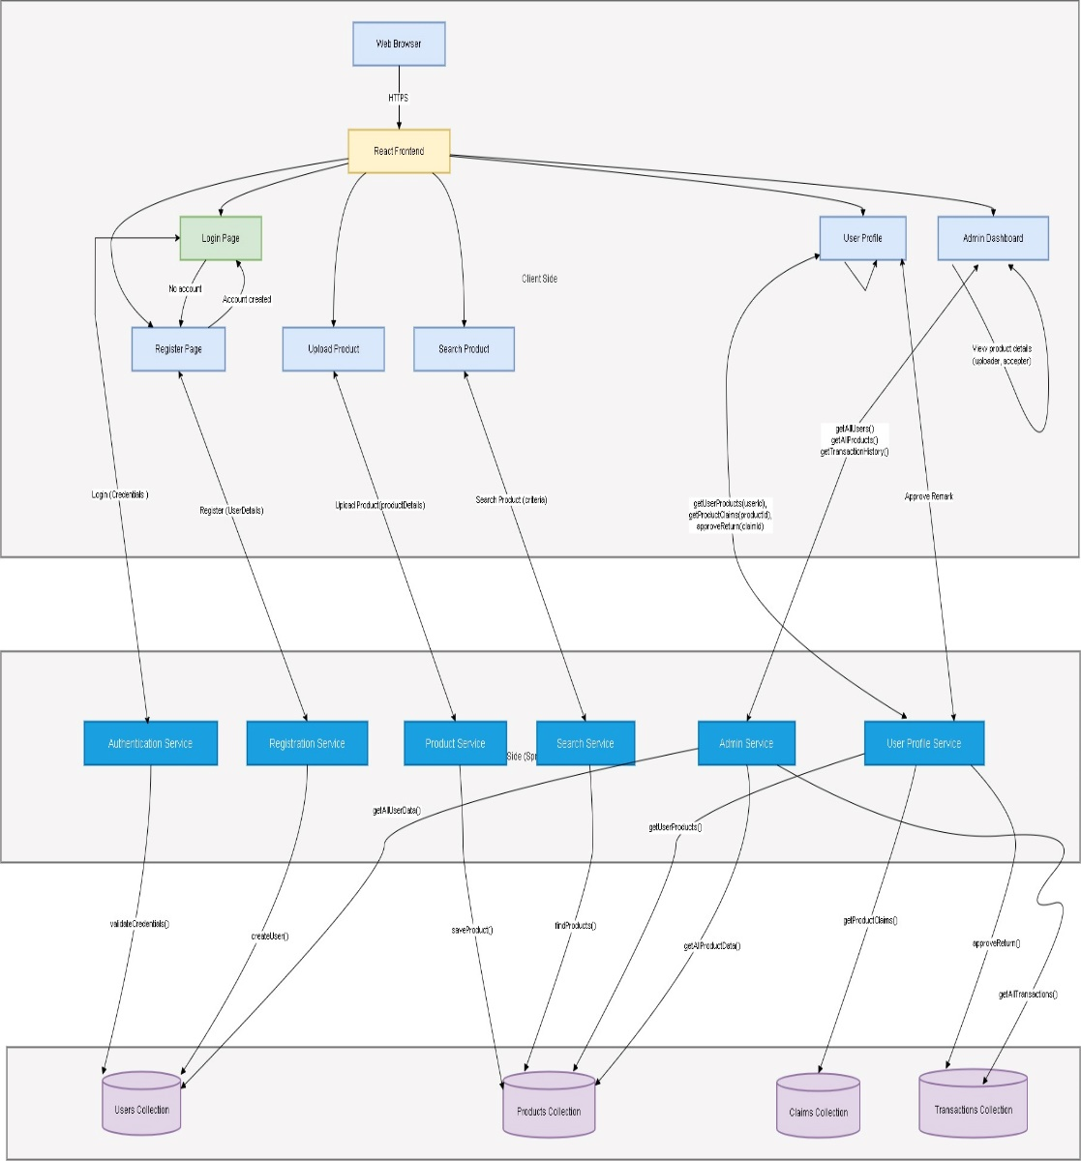

**Figure 1: System diagram.**

To ensure that items are returned to their rightful owners, the system incorporates a **secure verification process**. When a potential match is found, the finder can request additional details from the owner, such as a unique identifier or security question answer, before releasing the item. This step reduces the risk of fraudulent claims and ensures that only verified individuals can retrieve their belongings. For unresolved cases or disputes, an administrative panel is provided where authorized staff can manually verify claims, review item details, and mediate conflicts.

The system’s architecture is designed with scalability and reliability in mind. The back-end processes are hosted on a cloud server to handle increased user traffic efficiently, and the database is optimized for real-time queries and updates. The platform also supports multi-language functionality, ensuring accessibility for a diverse campus community. This flow ensures a seamless and user-friendly experience, reducing the workload of campus administrative staff while offering a secure and efficient solution for lost and found management.

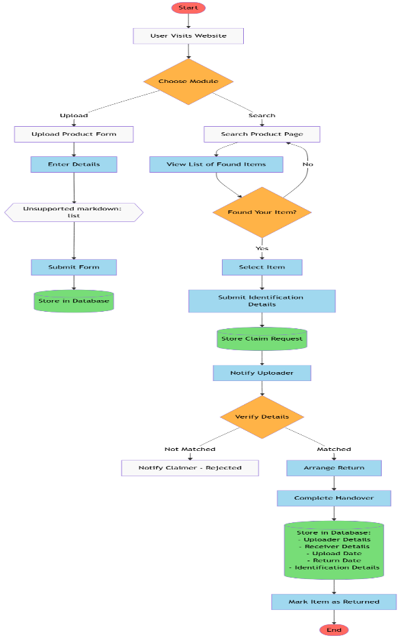

Reference

CONCLUSIONS AND FUTURE WORK

FoundIt: Your Campus Return & Recovery streamlines the lost and found process on college campuses by providing a secure, user-friendly, and efficient digital platform. Features like real-time notifications, secure verification, and multi-language support ensure accessibility and reliability, while an administrative panel reduces staff workload and ensures rightful ownership of items. By automating manual processes, the system saves time and fosters trust within the campus community.

Future enhancements include integrating **AI-based matching algorithms** for better accuracy, developing a **mobile application** for on-the-go access, and incorporating **GPS-based location services** to pinpoint found items. Additionally, integration with **campus ID systems** and scaling the platform to support multiple institutions would further expand its usability. These improvements will ensure FoundIt remains an innovative and adaptable solution for lost and found management.

Acknowledgement

We would like to express our heartfelt gratitude to *Dr. D. Y. Patil Pratisthan’s College Of Engineering, Salokhenagar, Kolhapur.* and the *Department of Computer Science and Engineering* for their guidance and support throughout the development of FoundIt: Your Campus Return & Recovery. We extend our sincere thanks to our project mentor, Mrs. Sneha Ghewari , for their valuable insights and encouragement, which were instrumental in the successful completion of this project.

We also thank our peers and the campus community for their constructive feedback and suggestions, which helped us shape the platform to meet real-world needs. Finally, we acknowledge the contributions of various resources and research materials that provided a strong foundation for this project. This endeavor would not have been possible without the collective efforts of everyone involved.

1. N. I. Alnaghaimshi, R. A. Alenizy, G. S. Alfayez, and A. A. Almutairi, "Mafqudat: Arabic Smartphone Application for Reporting Lost and Found Items," *Department of Computer Science and Information, College of Science, Majmaah University*, Al-Majmaah, Saudi Arabia.
2. Pushpa Choudhary, Arjun Singh, Akhilesh Kumar Choudhary, and Arun Pratap Srivastava, "Find Mine: Find the Lost Items via Mobile App," *Department of Information Technology, G. L. Bajaj Institute of Technology and Management*, Greater Noida, India.
3. Peters, J., and Smith, J., "Investigating Strategies for Locating Lost Items in Indoor Environments," *Journal of Behavioral Studies*, vol. 15, no. 3, pp. 120–133, 2018.
4. Lac, J., and Chan, P., "Using BLE Tags for Tracking Lost Items in Outdoor Spaces," *International Conference on Wireless Communication*, pp. 45–52, 2019.
5. Chan, P., and Wang, H., "RFID and GPS-Based System for Locating Tagged Items," *Journal of Emerging Technologies*, vol. 22, no. 4, pp. 300–312, 2020.
6. UK Finance, "Fraud and Lost Items Report 2018," *UK Finance Publications*, pp. 1–25, 2018.
7. FoundIt Development Team, *FoundIt: System Overview and Features*, Internal Project Documentation, 2024.